
Quick Start for BDD 2007
A Guide for Quickly Learning How to Use BDD 2007 in Lite-Touch Scenarios
By Jerry Honeycutt
Published: April 2007
Abstract
This guide introduces you to the Microsoft® Solution Accelerator for Business Desktop Deployment (BDD) 2007. Using this guide, you can quickly learn how you can use the solution to perform a basic Windows Vista™ installation. After mastering basic installation, you can more easily use the solution’s more advanced features.

The information contained in this document represents the current view of Microsoft Corporation on the issues discussed as of the date of publication. Because Microsoft must respond to changing market conditions, it should not be interpreted to be a commitment on the part of Microsoft, and Microsoft cannot guarantee the accuracy of any information presented after the date of publication.
This white paper is for informational purposes only. MICROSOFT MAKES NO WARRANTIES, EXPRESS OR IMPLIED, IN THIS DOCUMENT.
Complying with all applicable copyright laws is the responsibility of the user. Without limiting the rights under copyright, no part of this document may be reproduced, stored in or introduced into a retrieval system, or transmitted in any form or by any means (electronic, mechanical, photocopying, recording, or otherwise), or for any purpose, without the express written permission of Microsoft Corporation.
Microsoft may have patents, patent applications, trademarks, copyrights, or other intellectual property rights covering subject matter in this document. Except as expressly provided in any written license agreement from Microsoft, the furnishing of this document does not give you any license to these patents, trademarks, copyrights, or other intellectual property.
© 2007 Microsoft Corporation. All rights reserved. Microsoft, Windows, Windows Server, Windows Vista, and the Windows logo and are either registered trademarks or trademarks of Microsoft Corporation in the United States and/or other countries.
The names of actual companies and products mentioned herein may be the trademarks of their respective owners. Microsoft Corporation • One Microsoft Way • Redmond, WA 98052-6399 • USA
Contents
Overview 3
Installing Required Components 5
Installing BDD 2007 6
Starting Deployment Workbench 7
Installing Additional Components 8
Stocking the Distribution Share 9
Creating an Operating System Build 10
Creating a Lab Deploment Point 12
Installing a Windows Vista Build 14
Summary 17

Overview
The Microsoft® Solution Accelerator for Business Desktop Deployment (BDD) 2007 provides technology for performing desktop deployment. However, its larger focus is on methodology and best practices; BDD 2007 is an implementation of industry-standard methodologies and best practices. By following the guidance in BDD 2007, you are putting into action these methodologies and best practices to manage complex projects—proven best practices that Microsoft uses for its own development projects and that are based on the Microsoft Solutions Framework (MSF). The BDD 2007 documentation, illustrated in Figure 1, describes these methodologies and best practices. At the center are the process and team guides, which describe how to manage the project and how all of the processes interrelate. The spokes are technical guides, each guide covering a different technical aspect of the project, usually performed by a team that is dedicated to that process.
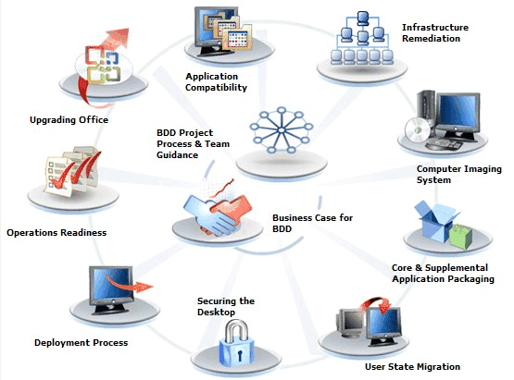
Figure 1. BDD 2007 Documentation
As shown in Figure 1, BDD 2007 contains a great deal of documentation—more than a thousand pages. Many information technology (IT) professionals try to plow through all this documentation just to determine whether they want to use the solution. While you should thoroughly read all the documentation before using the solution in a production deployment, sometimes you just want to evaluate or learn about the solution.
This white paper helps you evaluate BDD 2007 without reading a single word of the documentation. It’s a step-by-step guide for using the solution to install Windows Vista™. No planning—just the steps necessary to install a basic Windows Vista build. After using this white paper to evaluate the solution, you can delve in to the solution’s guidance to learn more about its advanced features.
To follow this white paper, you need the following elements:
- A lab environment. You need any two networked computers. Although you can use physical computers, using virtual machines (VMs) is easier. This white paper uses Microsoft Virtual Server 2005 R2. You can also use Microsoft Virtual PC 2007 to follow this white paper’s instructions.
- Windows Server® 2003 installed on one of the lab computers. This computer is the one on which you’ll install BDD 2007 and that you’ll use to create a basic Windows Vista build. This white paper refers to this computer as the build server.
- Windows Vista installation media. To follow this white paper, you need Windows Vista. You can use any edition of Windows Vista to evaluate BDD 2007, but this white paper recommends that you use the Windows Vista Business, Ultimate, or Enterprise edition.
This white paper describes two VMs. The first is inverness-bdd-srv-01, the domain controller for the WOODGROVE domain and also the build server. The second is inverness-bmc-cli-01. This VM is the destination computer with an unformatted virtual hard disk. Also, the administrator account is Administrator, and the password is P@ssword. Both VMs have 16 GB hard disks.
Note This white paper assumes that you’re evaluating BDD 2007 on x86 VMs or physical computers. If you’re evaluating the solution on x64 platforms, download and install the x64 editions of BDD 2007 and the components that this white paper describes.

Installing Required Components
BDD 2007 requires several components to begin. Download and install all the components shown in Table 1 before starting the solution (you don’t need to install these components if they’re already installed). You can download additional components after starting BDD 2007, as described in the section “Installing Additional Components,” later in this white paper.
Table 1. Required Components
Download this component | From this URL
Microsoft .NET Framework 2.0 | http://www.microsoft.com/downloads/details.aspx?FamilyID=0856eacb-4362-4b0d-8edd-aab15c5e04f5&DisplayLang=en
Microsoft Core Extensible Markup Language (MSXML) Services 6.0 | http://www.microsoft.com/downloads/details.aspx?FamilyID=993c0bcf-3bcf-4009-be21-27e85e1857b1&DisplayLang=en
Microsoft Management Console (MMC) 3.0 | http://www.microsoft.com/downloads/details.aspx?FamilyID=4c84f80b-908d-4b5d-8aa8-27b962566d9f&DisplayLang=en

Installing BDD 2007
The next step is to download and install BDD 2007 on the build server. You download BDD 2007 from http://www.microsoft.com/technet/desktopdeployment/bdd/2007/default.mspx (click Download BDD 2007 at the top of the Web page). After downloading BDD 2007, complete the following steps to install BDD2007_x86.msi on the build server:
- Right-click BDD2007_x86.msi, and then click Install.
- Click Next to skip the welcome page.
- On the End-User License Agreement page, review the license agreement. If the terms are agreeable, click I accept the terms in the License Agreement, and then click Next.
- On the Custom Setup page, click Next to install the typical features in their default locations:
- Documents. This feature installs the solution’s guidance and job aids. By default, this feature is installed in C:\Program Files\BDD 2007\Documentation.
- Tools and templates. This feature installs the solution’s wizards and template deployment files, such as Unattend.xml. By default, this feature is installed in C:\Program Files\BDD 2007.
- Distribution share. This feature creates a distribution share. By default, the installer creates the distribution share in D:\Distribution, where D is the volume with the most free disk space.
- Click Install to install the solution; then, click Finish to complete the installation.

Starting Deployment Workbench
To use the Deployment Workbench for tasks other than reviewing the documentation, you must log on to the computer using an account that is a member of the local Administrators group. To start Deployment Workbench, which is shown in Figure 2, click Start, point to All Programs, point to BDD 2007, and then click Deployment Workbench. The console tree shows the following items:
- Information Center. This item provides access to the documentation, breaking news about BDD 2007, and the components required for using the Deployment Workbench.
- Distribution Share. Under this item are the operating systems, applications, operating system packages, and out-of-box drivers that the distribution share contains. They are source files that BDD 2007 uses to install and configure operating systems.
- Builds. Under this item are operating-system builds, which describe how to install and configure an operating system.
- Deploy. The Deploy item contains two items below it: Deployment Points and Database. Deployment points provide access to builds and describe how to install them. You can use the database to define settings for individual computers, geographies, and so on.
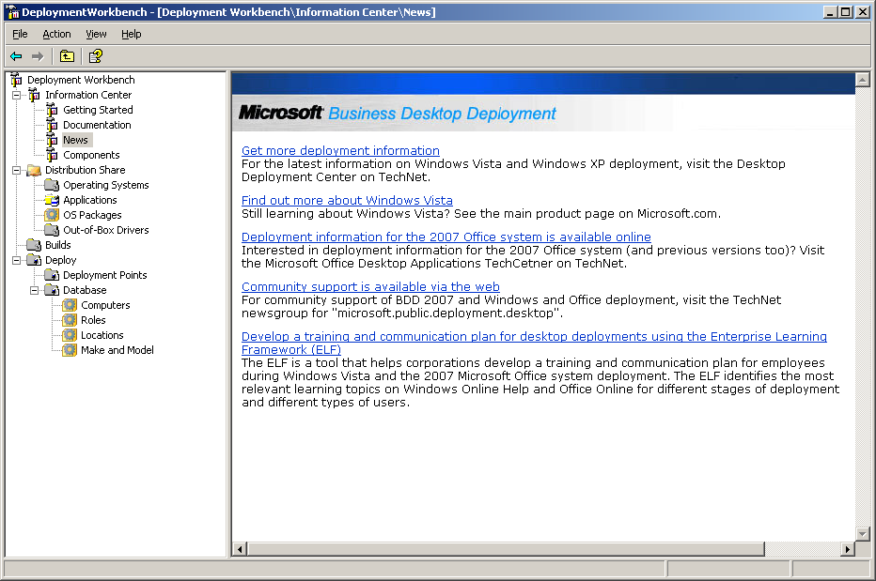
Figure 2. Deployment Workbench

Installing Additional Components
The components you installed in the section “Installing Required Components” are the minimum requirements to start Deployment Workbench. BDD 2007 requires other components to create and deploy images. The most notable component is the Windows Automated Installation Kit (AIK). The following steps describe how you download and install the Windows AIK by using the Components node of Deployment Workbench:
- In Deployment Workbench, click Components. Components is under Information Center.
- In the Available for Download section of the Details pane, click Windows Automated Installation Kit (x86), and then click Download. After downloading the Windows AIK, Deployment Workbench copies the files Waikx86.msi and Winpe.cab to C:\Program Files\BDD 2007\WAIK.
- In the Downloaded section of the Details pane, click Windows Automated Installation Kit (x86), and then click Install to automatically install the Windows AIK. Follow the instructions in the Windows AIK installer to complete the installation.
You can download and install other components in the Components node of Deployment Workbench. Examples include the User State Migration Tool (USMT) and the Application Compatibility Toolkit (ACT).

Stocking the Distribution Share
Using Deployment Workbench, you can stock the distribution share with the following source files, all of which the solution combines during installation to install and configure operating systems on destination computers:
- Operating systems
- Applications
- Operating system packages, including updates and language packs
- Out-of-box device drivers
When you add operating systems, applications, operating system packages, and out-of-box device drivers to the distribution share, you are simply storing the source files in the distribution share folder specified during BDD 2007 installation (D:\Distribution). You associate them with builds later in the configuration process.
This white paper describes how to install a basic Windows Vista build, so Windows Vista is the only source that you must add to the distribution share. To install a basic Windows Vista build, complete the following steps:
- In the Deployment Workbench console tree, right-click Operating Systems (which is under Distribution Share), and then click New to start the New OS Wizard.
- On the Choose the type of operating system to add page, select Full set of source files, and then click Next.
- On the Select the location of the operating system files page, type the path containing the Windows Vista source files to be added to the distribution share, and then click Next.
- On the Specify the destination page, click Copy to use the default folder name for Windows Vista and begin copying the files in to the distribution share.
This copy process can take several minutes to finish.
After adding Windows Vista to the distribution share, the operating system appears in the details pane of Operating Systems. Also, the operating system appears in the distribution share in Operating Systems\subfolder, where subfolder is the destination specified when adding the operating system.

Creating an Operating System Build
With Windows Vista added to the distribution share, you’re ready to create a build that describes how to install and configure it. For this white paper, you’ll create a basic, default build. To do so, complete the following steps:
- In the Deployment Workbench console tree, right-click Builds, and then click New to start the New Build Wizard.
- On the Specify general information about this build page, provide the following information, and then click Next:
- Build ID. Type LAB01.
- Build name. Type Windows Vista.
- Build comments. Type Installs a default Windows Vista configuration.
- On the Select an operating system image to use with this build page (Figure 3), choose a Windows Vista image to use, such as Windows Vista BUSINESS, and then click Next.
You added Windows Vista to the distribution share in the previous section.
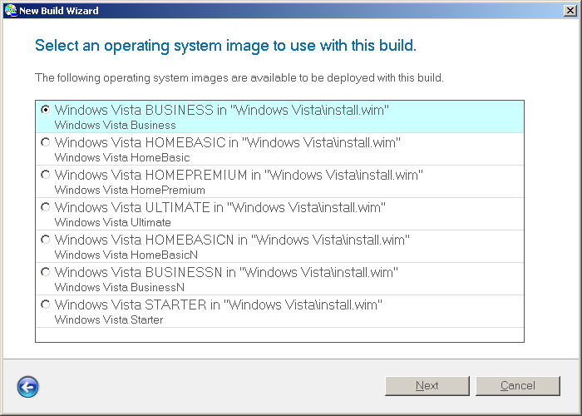
Figure 3. New Build Wizard
- On the Specify the product key for this operating system page, select Do not specify a product key at this time, and then click Next.
- On the Specify settings about this build page, provide the following information, and then click Next:
- Full Name. Type Valued Woodgrove Bank Employee.
- Organization. Type Woodgrove Bank.
- Internet Explorer Home Page. Type http://www.woodgrove.com.
- On the Specify the local Administrator password for this build page, select Use the specified local Administrator password, type P@ssword in the spaces provided, and then click Create.
After adding a build to the distribution share, it appears in the Builds details pane. Also, it appears in the distribution share in Control\subfolder, where subfolder is the build ID.

Creating a Lab Deploment Point
In BDD 2007, deployment points describe how to access builds and how to install them. BDD 2007 supports different types of deployment points:
- Lab or single-server deployment (Lab). Deploy builds from the distribution share created on the build server.
- Separate deployment share (Network). Create another distribution share on the build server or another network-accessible computer. The new distribution share will contain a subset of the files contained in the local distribution share.
- Removable media (Media). Create a DVD ISO image to deploy a build. This type of deployment point is useful for deploying builds to mobile users and branch offices.
- SMS 2003 OSD (OSD). Create a directory containing all the files required to customize a Microsoft Systems Management Server (SMS) 2003 Operating System Deployment (OSD) Feature Pack program. For more information about using BDD 2007 with the SMS 2003 OSD Feature Pack, see the Zero Touch Installation Guide in BDD 2007.
You must always create a lab deployment point in Deployment Workbench. This white paper uses a lab deployment point to install a basic, default Windows Vista build. To create the lab deployment point, complete the following steps:
- In the Deployment Workbench console tree, right-click Deployment Points (which is under Deploy), and then click New to start the New Deployment Point Wizard.
- On the Choose which you would like to configure or create page, select Lab or single-server deployment, and then click Next.
- On the Specify a descriptive name page, click Next to accept the default name LAB.
- On the Allow Application Selection during Upgrade page, click Next.
- On the Specify whether to prompt for image capture page, click Next.
- On the Allow user to set Administrator password page, click Next.
- On the Allow user to specify a product key page, click Next.
- On the Specify the location of the network share to hold the files and folders necessary for this deployment type page, shown in Figure 4, click Next.
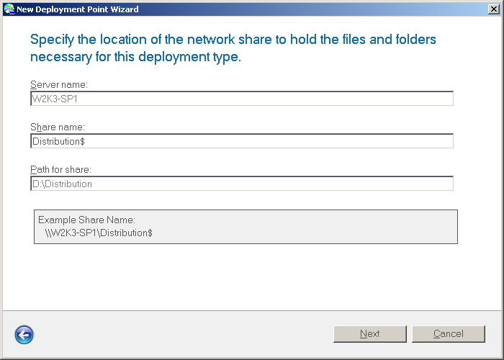
Figure 4. New Deployment Point Wizard
- On the Specify user data defaults page, select Do not save data and settings, and then click Create.
After creating lab deployment point in Deployment Workbench, update it to create it on the file system. Updating a deployment point creates the folder structure, Microsoft Windows Preinstallation Environment (Windows PE) boot images, and so on. To update a deployment point, right-click the deployment point you want to update in the Deployment Points details pane, and then click Update.

Installing a Windows Vista Build
To install the basic Windows Vista build, start a lab computer using the Windows PE bootable images generated by updating the deployment point in the previous section. You update the deployment point to generate the Windows PE bootable images.
Start the Windows PE bootable images in either of two ways. First, burn LiteTouchPE_x86.iso to a DVD. This image file resides in the \Boot folder of the distribution share. If you’re evaluating BDD 2007 using VMs, simply mount the ISO image to the destination machine after copying the image file to an accessible location. After burning the image to a DVD or mounting the image, restart the destination computer.
Second, add the LiteTouchPE_x86.wim image file to the Boot Images item of a Microsoft Windows Deployment Services server. The .wim image files reside in the \Boot folder of the distribution share. For more information about installing and configuring Windows Deployment Services, see the Windows Deployment Services Update Step-by-Step Guide for Windows Server 2003 at http://technet2.microsoft.com/WindowsVista/en/library/9e197135-6711-4c20-bfad-fc80fc2151301033.mspx?mfr=true. Then, restart the computer using the boot image you added to Windows Deployment Services.
After starting the lab computer using the Windows PE image, complete the following steps to install the basic Windows Vista build:
- In the Welcome to Windows Deployment dialog box, shown in Figure 5, click Run the Deployment Wizard to install a new operating system, and then click Next.
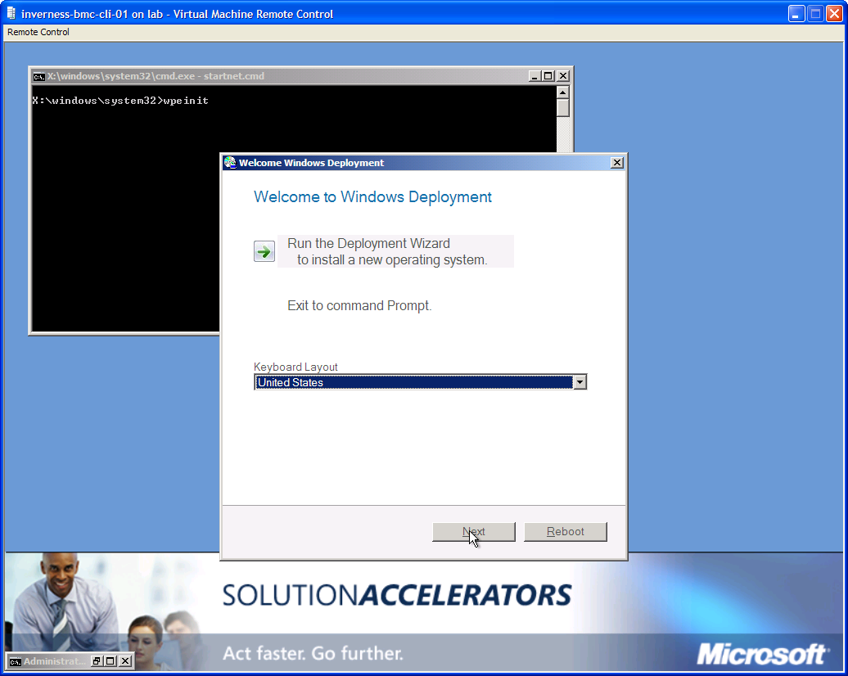
Figure 5. Welcome to Windows Deployment
- In the User Credentials dialog box, type the credentials (user name, domain, and password) necessary to connect to the distribution share, and then click OK.
In the lab environment this white paper describes, the user account is WOODGROVE\Administrator, and the password is P@ssword. The Windows Deployment Wizard starts automatically.
- On the Configure the computer name page, accept the default computer name, and then click Next.
- On the Join the computer to a domain or workgroup page, click Join a workgroup. In the Workgroup box, accept the default workgroup name, and then click Next.
- On the Specify whether to restore user data page, select Do not restore user data and settings, and then click Next.
- On the Select an operating system image to install page, choose Windows Vista from the list of available builds, and then click Next.
This is the build you created in the section, “Creating an Operating System Build.”
- On the Locale Selection page, click Next.
- On the Set the Time Zone page, click Next.
- On the Specify whether to capture an image page, select Do not capture an image of this computer, and then click Next.
If you select Capture an image of this reference computer, BDD 2007 installs the build on the computer, prepares it for imaging, and automatically captures and stores the image for you.
- On the Ready to begin page, click Begin.
After clicking Begin, BDD 2007 begins installing the build. By default, it begins by partitioning and formatting the hard disk. Then, it installs and configures the build.

Summary
In this white paper, you learned how to install BDD 2007 and how to use it to deploy a basic build of Windows Vista. For more information about using BDD 2007 to deploy Windows Vista visit the Desktop Deployment Center at http://www.microsoft.com/technet/desktopdeployment/bdd/2007/default.mspx?WT.mc_id=bddfr, where you can read all of the BDD 2007 documentation.
The BDD 2007 solution accelerator is far more than just technical guidance. It also includes best practices and project management guidance. For more information about planning a deployment project, see the Plan, Build, and Deploy Guide at http://www.microsoft.com/technet/desktopdeployment/bdd/2007/PbdGuide.mspx.

